Rohit Lad
  - Game/Level designer

About Me
I am passionate about video games. My interest evokes my imagination power. I can visualize things that help me design games and realize them to a product. I have the knowledge and drive to put things in order. I can create any game world in which players can indulge themselves in.

Skills
Game Engines: Unity 3D, Unreal Engine 4
3D Modelling packages: Autodesk 3ds Max
Programming language: C, C# scripting
Source Control: Unity collaboration, GitHub
Editing Tools: Adobe Photoshop, Adobe Illustrator, MS Visio
Production tools: MS Project, MS Office suite, Google Docs, Kanban board
QA and bug tracking: Hack n Plan, Trello

Project Experience

Level Designer – Tumble (Mobile Casual Puzzle)
Winter Park FL
(May 2020 - Present)
- Creating and maintaining level design docs in Google Docs
- Level desining and layout creation in Adobe Illustrator
- Level blockouts and mechanics prototyping in Unity 3D
- Level design implementation in Unity 3D
- Game audio implementation

Lead GAME DESIGNer – Humanity SaVR! (VR shooter)
Zygobot Studios, Winter Park FL

(Jan 2020-Present)
- Game production documentation in MS Excel
- Creating and maintaining level design documentation using MS Office suite
- Oculus Integration for Unity 3D
- Game audio implementation
- Digital prototyping and level block out in Unity 3D
- Level designing and art implementation using Unity 3D
- Scripting in C# for custom weapons and weapon system
- Game optimization for Oculus VR headsets

LEAD Game Designer – dino tank (Vehicular shooter)
Zygobot Studios, Winter Park FL

(Dec 2018-Present)
- Task management and tracking for the design team using Hack n Plan and Kanban board
- Level design documentation using MS Office suite
- Level designing and implementation using Unity 3D
- Art assets and systems integration in Unity 3D with GitHub for source control
- Assets integration into the monthly build
- Mechanics scripting and implementation with C# scripting
- Design shadow master

LEvel designer/integration engineer – the culling exam (3D escape room puzzle)
Full Sail University, Winter Park FL

(April 2019-June 2019)
- Available on itch.io
- Game production documentation in MS Project
- Level design and mockups using Google Draw
- Weekly build with all assets integrated with GitHub and Unity 3D
- Third-person camera scripting and implementation in C# scripting
- QA analysis and bug tracking using Google Sheets

QA/Game Designer – Elevator pitch
Full Sail University, Winter Park FL
(Nov 2018-Dec 2018)
- QA testing and analysis using Hack n Plan and Google Sheets
- Level mockups in Google Draw
- Maze mockups in Google Draw
- Puzzle creation in Adobe Photoshop

Achievements
- Microsoft Student Partner in FY 2015-16 for Microsoft India conducting workshops and spreading awareness in rural India about the latest technology. Also, participating in hackathons to design and deploy quick solutions to a problem.
- The only student to receive the Valedictorian award for the highest GPA in the class.

Publications
Hand-Gesture Recognition for Automated Speech Generation 2016 IEEE International Conference on Recent Trends in Electronics, Information & Communication Technology (RTEICT-2016) Jan 2017, pp. 226-231
http://ieeexplore.ieee.org/stamp/stamp.jsp?tp=&arnumber=7807817&isnumber=7807761

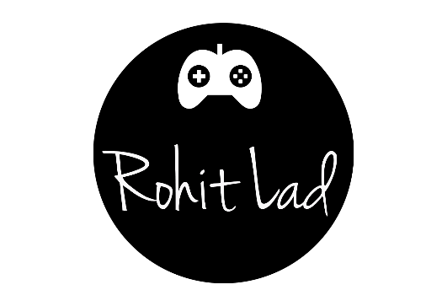
 | C O N T A C T
 |  | rohit.lad@hotmail.com
 |  | +1 (714) 773-2964
 |  | www.rohitlad.com
 |  | E D u c a t i o n
 |  | Full sail university, FL  MS in Game Design, Valedictorian  Oct. 2019 – 3.93 GPA

University of pune, india
Bachelor’s in Information Technology

June 2016

